Graph Theory – Classifying Graphs Name___________________Per___

Graph: collection of vertices and edges
Undirected graph: all edges are assumed to be bidirectional
Degree: number of connections
Isolated vertex: a vertex with degree zero; that is, a vertex that is not an endpoint of any edge
Leaf vertex: a vertex with degree one.
Directed graph: direction of edges are indicated
Indegree: number of inbound connections
A simple undirected weighted cyclic graph:
Outdegree: number of outbounds connections
Source vertex: a vertex in a directed graph with indegree zero
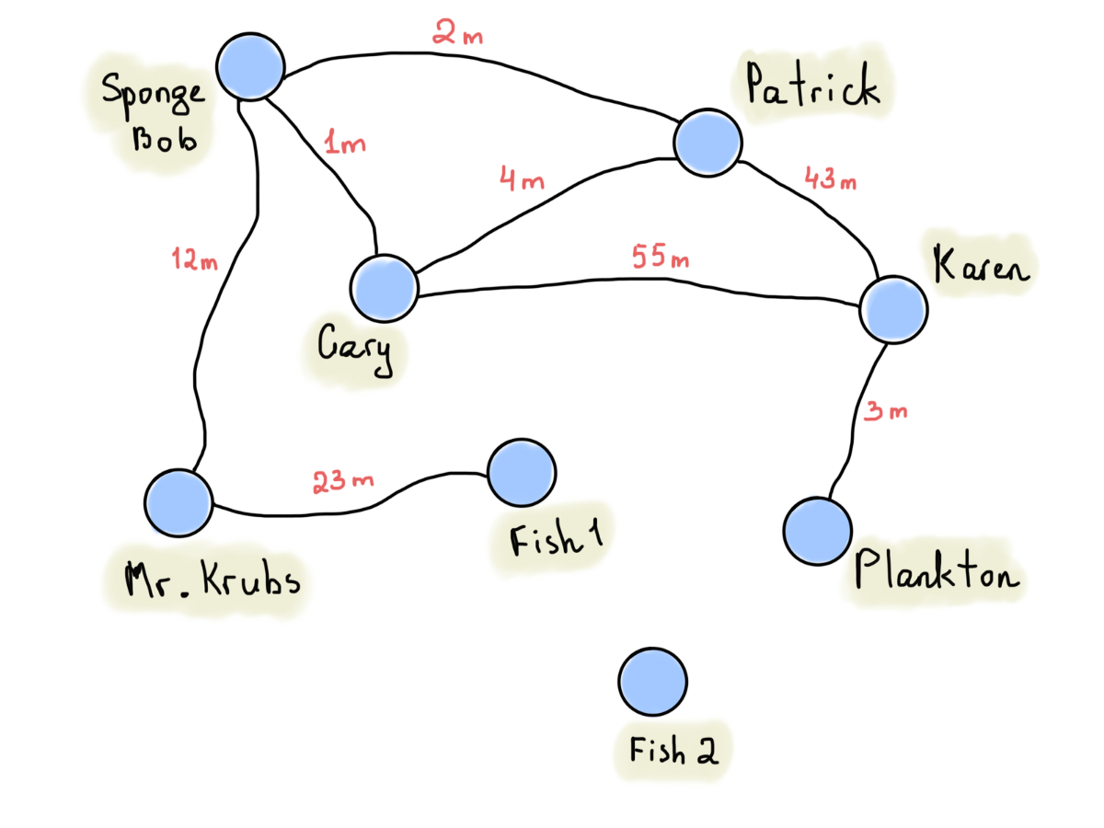Sink vertex: a vertex a directed graph with outdegree zero
Walk: list of vertices in which successive vertices are connected by edges: SB-MK-F1
Trail: a walk which has no repeating edges:
Gary-Patrick-SpongeBob-Gary-Karen-Plankon
Path: a trail which has no repeating vertices:
SpongeBob-Gary-Karen
Cycle: a trail in which the only repetition is the start and
end: Gary-Patrick-Karen-Gary
Directed cycle: The same definition as above, but since each directed edge is distinct, you could have a cycle of length two, whereas in an undirected graph you can have cycles of length one (if there’s a loop) or length three, but not length two as that would necessitate traversing the same edge twice.
Simple Graph: doesn’t contain multiple edges between nodes nor loops. A simple directed graph has no multiple arrows with same source and target nodes.
Non-simple Graph: contains multiple edges between at least one pair of nodes OR has at least one loop.
Connected graph: path exists from every vertex to every other vertex
Unconnected graph: a graph that is not connected and is made up of connected components
Tree: An undirected graph in which any two vertices are connected by exactly one path.
I.e. a connected acyclic undirected graph. I.e. a connected graph that does not contain even a single cycle.
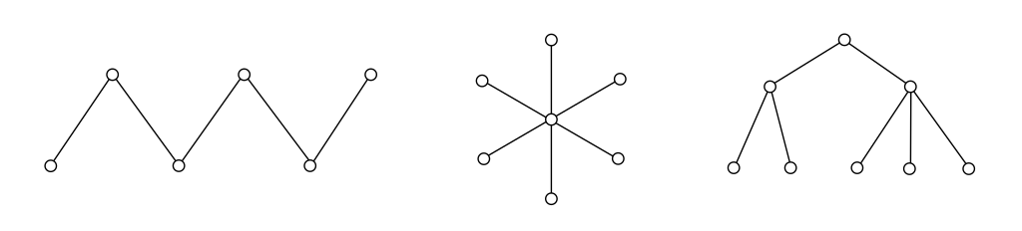
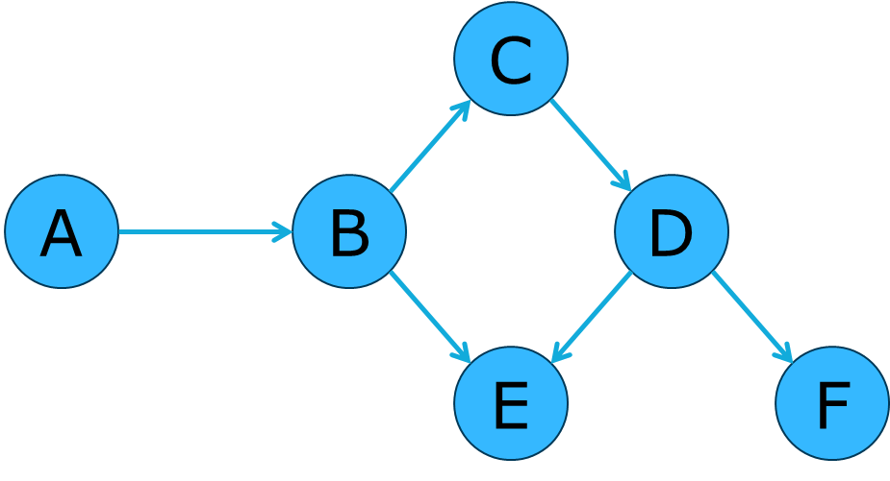Directed Acyclic Graph (DAG):
a directed graph with no cycles

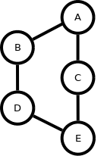Cyclic Graph: A graph with at least one cycle.
Circular Graph: A graph that is a cycle.
Complete Graph: A simple graph in which each pair of distinct vertices are adjacent.
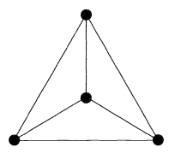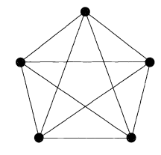
Adjacency matrix: matrix containing 1’s and 0’s indicating an existing directed edge between vertices.
1 = edge exists, 0 = edge does not exist

A directed cycle is just a cycle on a directed graph, but since each directed edge is distinct, you could have a cycle of length two, whereas in an undirected graph you can have cycles of length one (if there’s a loop) or length three, but not length two as that would necessitate traversing the same edge twice.

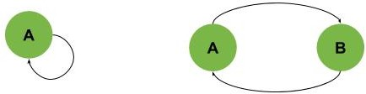

Remember that in directed graphs, each arrow is considered to be a separate connection. So ED and DE are distinct edges. This means EDE would count as a cycle!

